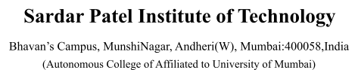

|  |  |
| --- | --- |
| **Team Member Name:** | **Team Member UID:** |
| Manish Shashikant Jadhav | 2023301005 |
| Mayur Krishna Solankar | 2023301018 |

|  |  |
| --- | --- |
| **EXPERIMENT NO.:** | 2 |
| **AIM:** | UML Diagram |

# Use Case Diagram:

**List of Actors**

|  |  |
| --- | --- |
| **Actor** | **Description** |
| User | Students are responsible for creating, editing and deleting account. |
| Visitor | Parents who can visit their children. |
| Admin | System administrators who manage users and visitors of HMS. |

**List of Use-Case**

:

|  |  |  |  |
| --- | --- | --- | --- |
| **#** | **Use Case** | | **Description** |
| UC 1 | Create Account | | Register and set up a new user account in the system; if the user already has an account,  provide a "Login" option. |
| UC  2 | Delete Account | | Permanently remove a user account and  associated data from the system. |
| UC 3 | Booking rooms | | Hostel management systems enable users to check availability, and book rooms or beds. |
| UC 4 | Check-In and Check-Out: | | Hostel staff can use the system to efficiently  check Students in and out, reducing wait times and paperwork. |
| UC 5 | Billing and Payments |  | The system calculates and generates invoices, automating the billing process for guests.  It can support various payment methods, |
|  | |





including cash, credit card, and online payment gateways.

**Use CaseScenarios**

**UC1:Create Account**

|  |  |  |
| --- | --- | --- |
| **Use Case:** | UC1: Create Account | |
| **Goal:** | Register and set up a new user account in the system; if the user already has an account, provide a "Login" option. | |
| **Actors:** | User, Admin | |
| **Pre-condition:** | None | |
| **Post-condition:** | The user either successfully creates a new account or logs into their  existing account. | |
| **Mainline Scenarios:** |  | |
| **Actor Actions** | **System Actions** |
| Provide Personal Information: The guest/student provides their personal details such as name,  contact information, identification (ID) proof, and address. | If all information is valid and complete, the system creates a  new guest/student account in the database. |
| Choose Username and Password: The guest/student  selects a unique username and password for accessing their  account in the future. | Once the account is created and verified, the system provides login access to the guest/student, allowing them to make reservations, view booking history, and manage their profile. |
|  | |
| **Alternate Flows:** | 4. If the user enters invalid information, the system displays an error message and prompts the user to correct the information. | |

**UC2:Delete Account**

|  |  |  |
| --- | --- | --- |
| **Use Case:** | UC2: Delete Account | |
| **Goal:** | Permanently remove a user account and associated data from the system. | |
| **Actors:** | User, Admin | |
| **Pre-condition:** | The user is logged into their account. | |
| **Post-condition:** | The user's account and associated data are permanently deleted. | |
| **Mainline Scenarios:** |  | |
| **Actor Actions** | **System Actions** |
| After logging in, the guest/student initiates the  account deletion process. This may involve navigating to an account settings or profile  section where the option to delete the account is available. | The system verifies the provided username and password to  ensure that the person initiating the account deletion is the legitimate account holder. |
| After providing the reason (if required), the guest/student  confirms their intention to delete the account. | The system logs the account deletion activity for audit and record-keeping purposes. |
|  | |
| **Alternate Flows:** | 3.User Doesn't Confirm Deletion. | |

**UC3:Booking rooms**

|  |  |
| --- | --- |
| **Use Case:** | UC3: Book room |
| **Goal:** | To check if there is any room available to book. |
| **Actors:** | User, Admin |
| **Pre-condition:** | The user is logged into their account. |

|  |  |  |
| --- | --- | --- |
| **Post-condition:** | The room is successfully allocated. | |
| **Mainline Scenarios:** |  | |
| **Actor Actions** | **System Actions** |
| The system displays a list of  available rooms that match the guest/student's criteria, along with their prices and descriptions. | The system checks room  availability for the specified check-in and check-out dates,  ensuring that the selected rooms are not already booked. |
| They review the booking details, including the selected room(s), dates, and total cost. | The system sends a booking confirmation to the guest/student, which may include check-in instructions  and other relevant information. |
|  | |
| **Alternate Flows:** | All rooms are occupied | |

**UC4:Check-in and Check-out**

|  |  |  |
| --- | --- | --- |
| **Use Case:** | UC4: Check-in and Check-out | |
| **Goal:** | To maintain students check-in and check-out timing. | |
| **Actors:** | User | |
| **Pre-condition:** | The user has account | |
| **Post-condition:** | The timings are successfully edited and updated | |
| **Mainline Scenarios:** |  | |
| **Actor Actions** | **System Actions** |
| They provide their identification (e.g., ID card, passport) to verify their identity. | The system may assist the front desk staff in verifying the guest/student's identification by cross-referencing it with the data provided during the booking process. |
| Once the check-in process is complete, they receive a room key or access card. | If the guest/student has a reservation, the system retrieves and displays the booking details for the front desk staff. |
|  | |
| **Alternate Flows:** | Student does not have an account | |

**UC5:Billing Payments**

UC5: Billing Payments

**Use Case:**

|  |  |  |
| --- | --- | --- |
| **Goal:** | To make payments securely | |
| **Actors:** | User | |
| **Pre-condition:** | The user is logged into their account. | |
| **Post-condition:** | Payment successful | |
| **Mainline Scenarios:** |  | |
| **Actor Actions** | **System Actions** |
| The guest/student requests a bill for their stay or additional  services they've used (e.g., room charges, room service, minibar). | The system generates an itemized bill that includes all charges and taxes, providing a clear breakdown for the guest/student. |
| After making the payment, they receive a payment receipt for their records. | The system maintains a history of payments for each guest/student, which can be useful for auditing and reporting purposes. |
|  | |
| **Alternate Flows:** | Payment fails | |

**Use Case Diagram:**

**////////////**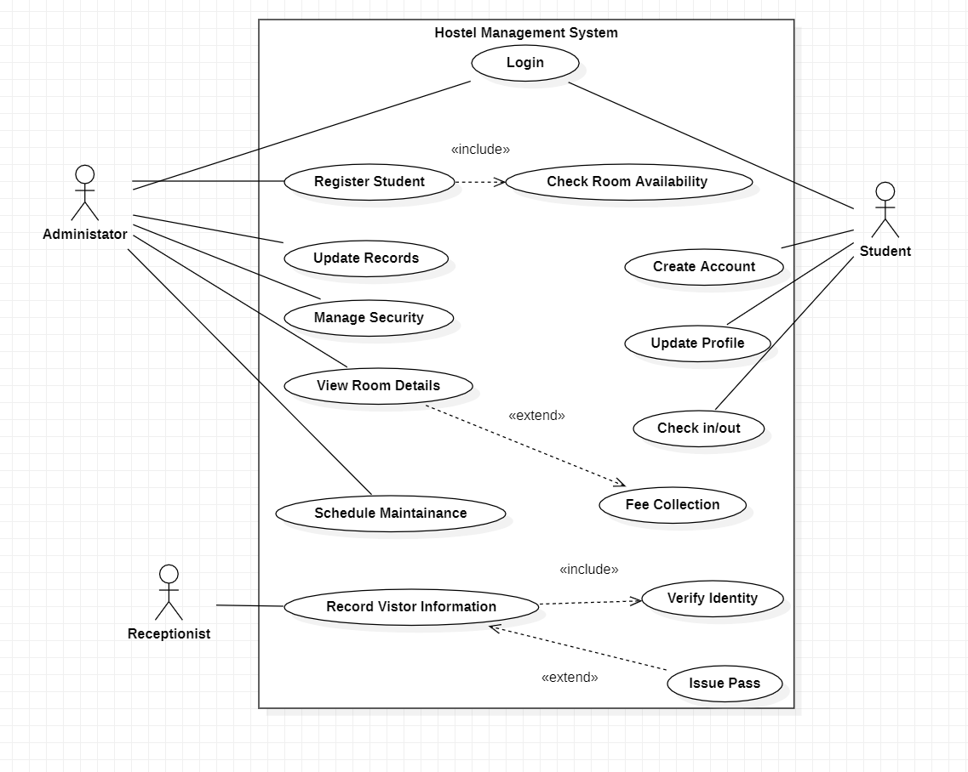

**Conclusion:** Hence by completing these experiment we came to know about designing of UML diagram.